

Bangladesh University of Business and Technology

Dept. name : Computer Science and Engineering Course name : Software Development Project Course code : CSE - 100

Project title : Inventory management system

Intake : 51

Section : 06

Group no : 01

Submitted To : Khan Md. Hasib Assistant Professor, Department of CSE, BUBT

Submitted By :

|  |  |
| --- | --- |
| Md Sultan Ahmed | **22235103227** |
| Md Tarikul Islam | **22235103242** |
| Sadat Islam | **22235103269** |
| Abu shaman Obhro | **22235103234** |
| Md Ali Akbar | **22235103237** |
| Md Jobayer Hossan | **22235103236** |



We would like to state that the discussion titled “student management system” that we have submitted for the course of Software Development 100, Department of CSE a project work that we have completed under the supervision of Khan Md.

Hasib and has not been given anywhere else.

We will be held accountable if any errors are discovered.

Date: 15-11-2023



We did everything we could to finish this project. We are new to this because it is our first software development project. However, we Md Sultan Ahmed , Md Tarikul Islam, Sadat Islam, Abu shaman Obhro , Md Ali Akbar, Md Jobayer Hossan were

able to complete our project. We made every effort to overcome our flaws. Also, thanks to our honorable teacher, Khan Md. Hasib, for his guidance. His advice helped us in overcoming our flaws and mistakes.



Our Student Management System project is a user-friendly, modular, and efficient software solution designed to automate administrative tasks related to student information in educational institutions. The system includes features such as student registration, attendance tracking, grade management, and report generation. Utilizing object-oriented programming principles and file handling, it provides a secure and scalable platform for administrators, teachers, and other stakeholders. The project aims to enhance the overall management of academic records, improving efficiency and accuracy in educational institutions.

 



Project aim and Objective ----------------------------------------------------

Development Environment ----------------------------------------------------



General Description -------------------------------------------------

Project Design -------------------------------------------------

Features -------------------------------------------------



User Interface -------------------------------------------------

Future work and conclusion --------------------------------------------------

References --------------------------------------------------





The C++ Student Management System project efficiently organizes student-related data in educational institutions. This report succinctly outlines the project's objectives, design, and implementation. It covers system architecture, data flow, and entity-relationship diagrams, along with implementation details using C++. The report discusses testing methods, project outcomes, and proposes future enhancements, all presented in a formal style with references and an appendix for additional information.



The C++ Student Management System project is developed in a conducive programming environment using appropriate tools and frameworks, ensuring an efficient and streamlined development process.





The C++ Student Management System project efficiently organizes student-related data in educational institutions. This report succinctly outlines the project's objectives, design, and implementation. It covers system architecture, data flow, and entity-relationship diagrams, along with implementation details using C++. The report discusses testing methods, project outcomes, and proposes future enhancements, all presented in a formal style with references and an appendix for additional information.

Project Design :

This project is designed for student management system

Details

Admission

About

Academic

Clubs

Main Menu

Features :

A simple student management system developed in C++ encompasses various essential features. These include student registration, enabling administrators to add, edit, or delete student records, containing vital personal information such as names, IDs, addresses, and contact details. Additionally, the system handles course management, allowing for the addition, modification, and removal of course details like course codes, titles, and descriptions. It also tracks student attendance, providing a mechanism to mark students as present or absent during class sessions. The system further manages student grades, allowing the entry, modification, and calculation of grades for assignments, quizzes, exams, and other assessments. User authentication is implemented to ensure that only authorized personnel can access and modify the system. Furthermore, the system offers search and filtering capabilities, making it easy to find student records based on various criteria. It can generate reports such as student transcripts, attendance summaries, and grade sheets, helping administrators and teachers monitor student progress. Data export and import functionalities are included for backups and data migration. A user-friendly interface simplifies navigation for both administrators and teachers, with basic security measures in place to protect student data and ensure data privacy. The system also incorporates data validation rules to maintain data accuracy and consistency and provides error handling mechanisms for unexpected issues. To prevent data loss, backup and restore features are included. User management allows administrators to add, modify, and delete user accounts with appropriate roles and permissions. The system is designed for scalability to handle a growing number of students and courses without performance degradation. Finally, a feedback system collects user input and suggestions for system improvement.





LOADING PAGE

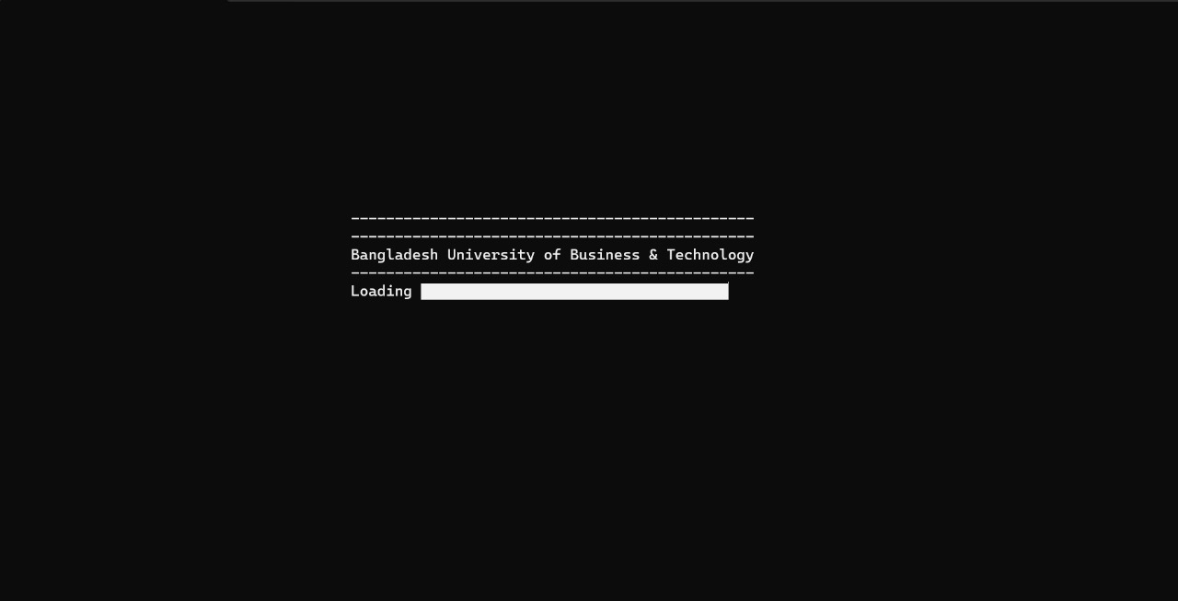

MAIN MENU

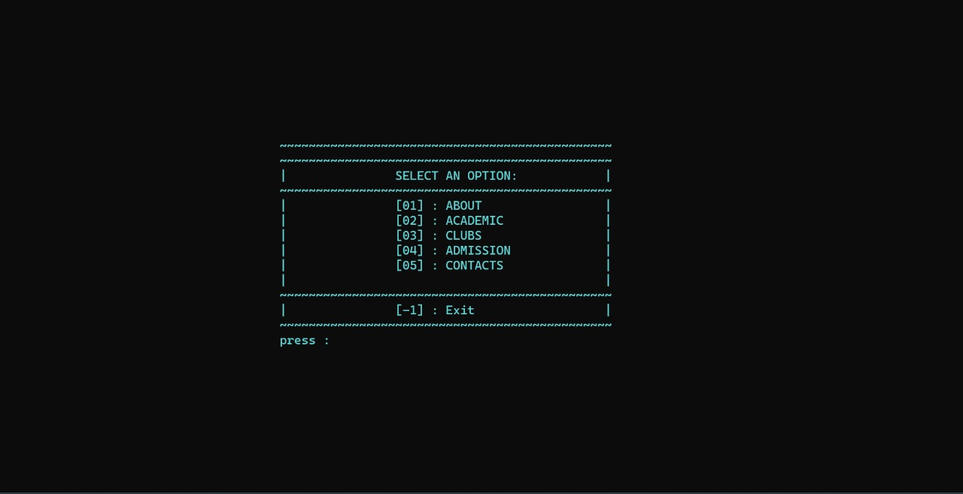

ABOUT SECTION

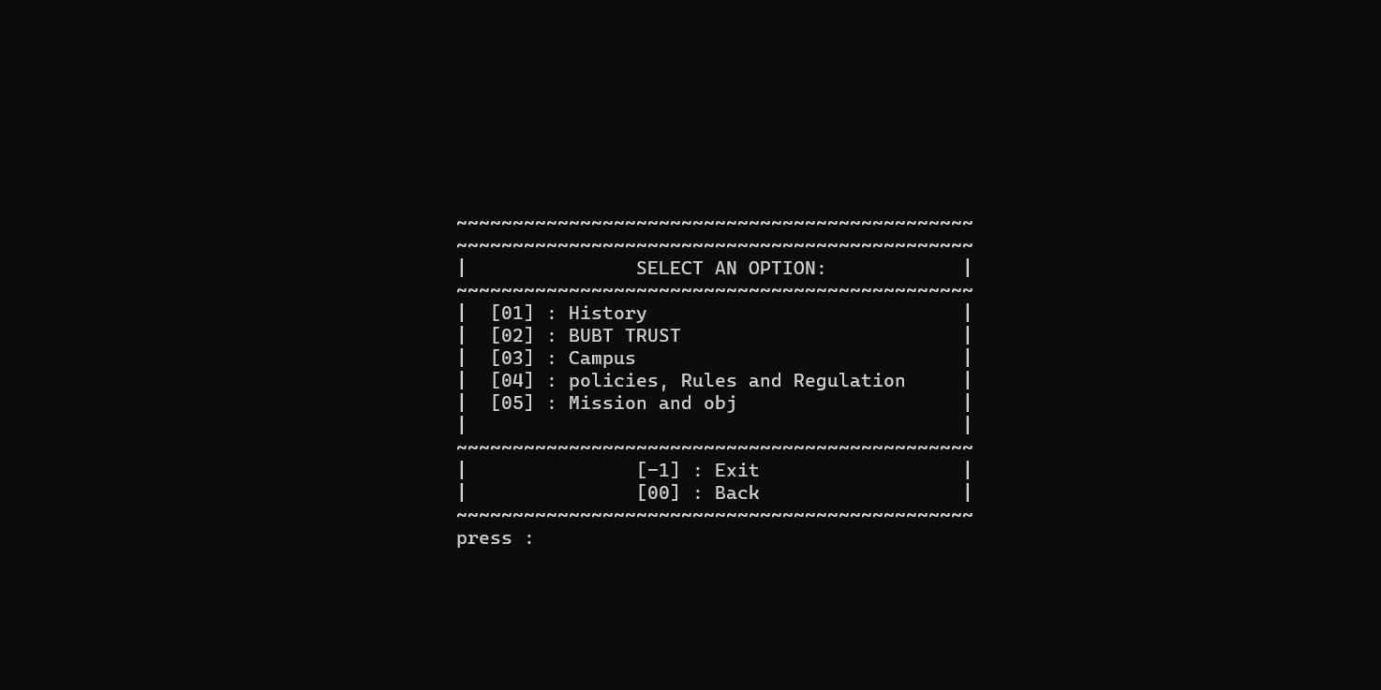

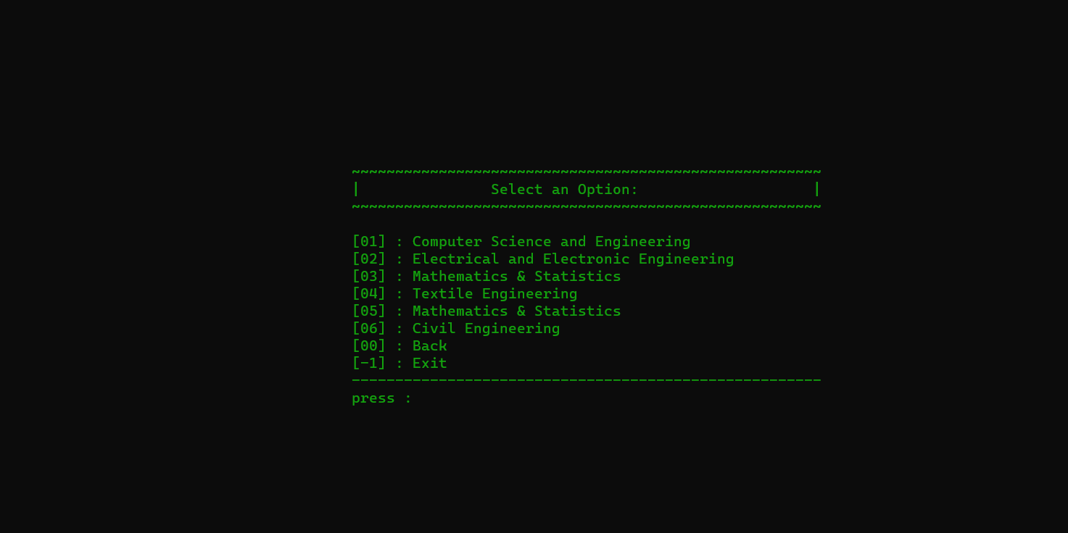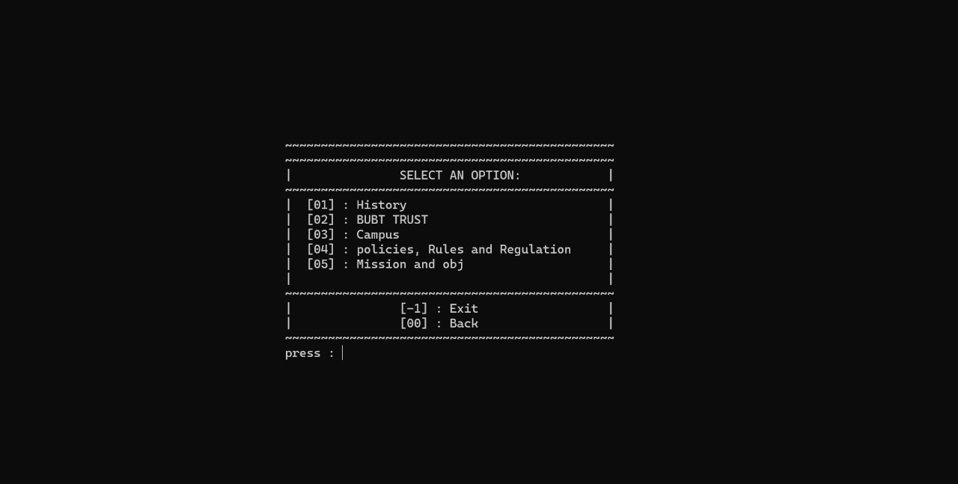

CLUB SECTION

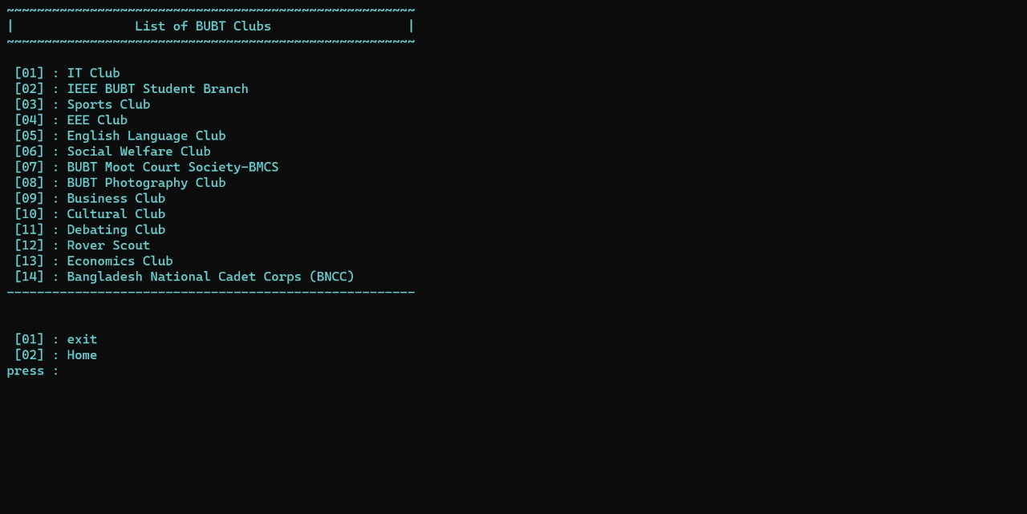

ACADEMIC SECTION

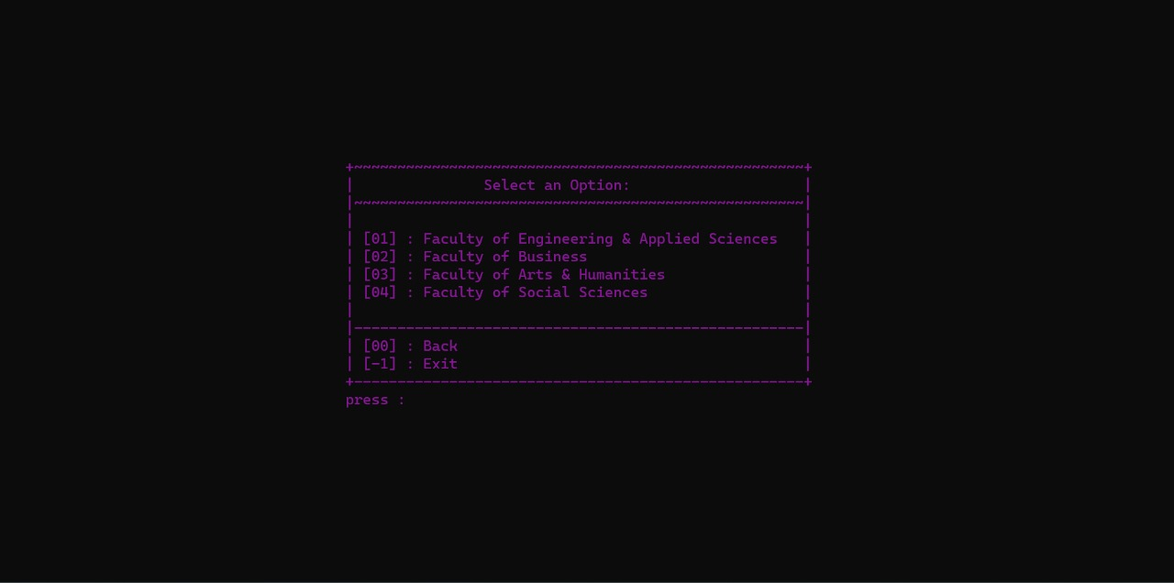

ADMISSION SECTION

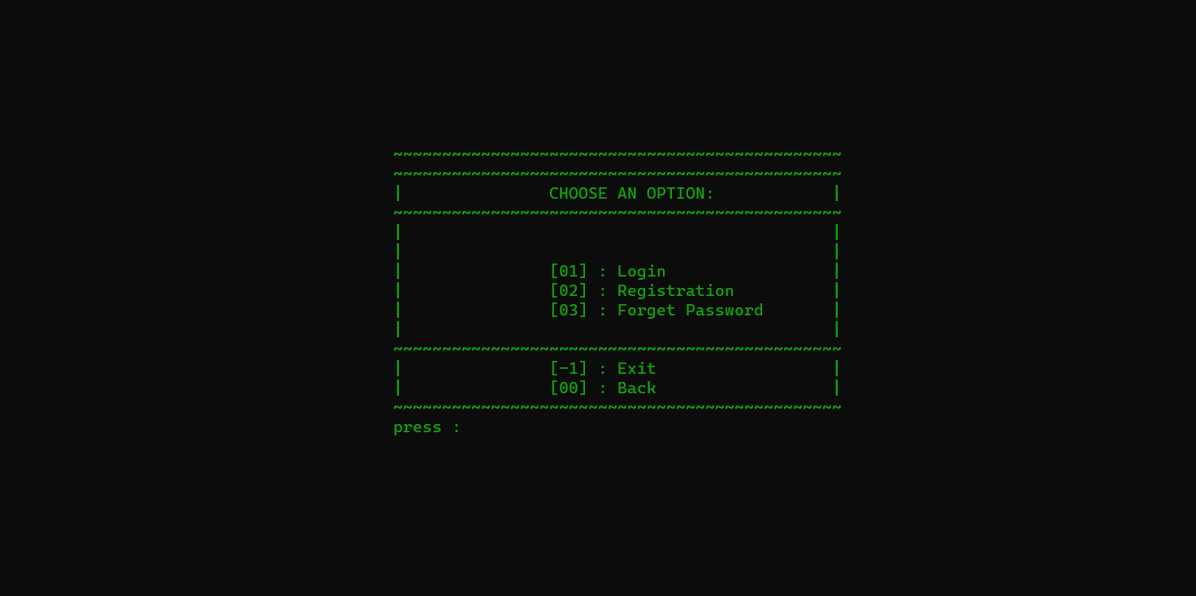

REGISTRATION FROM

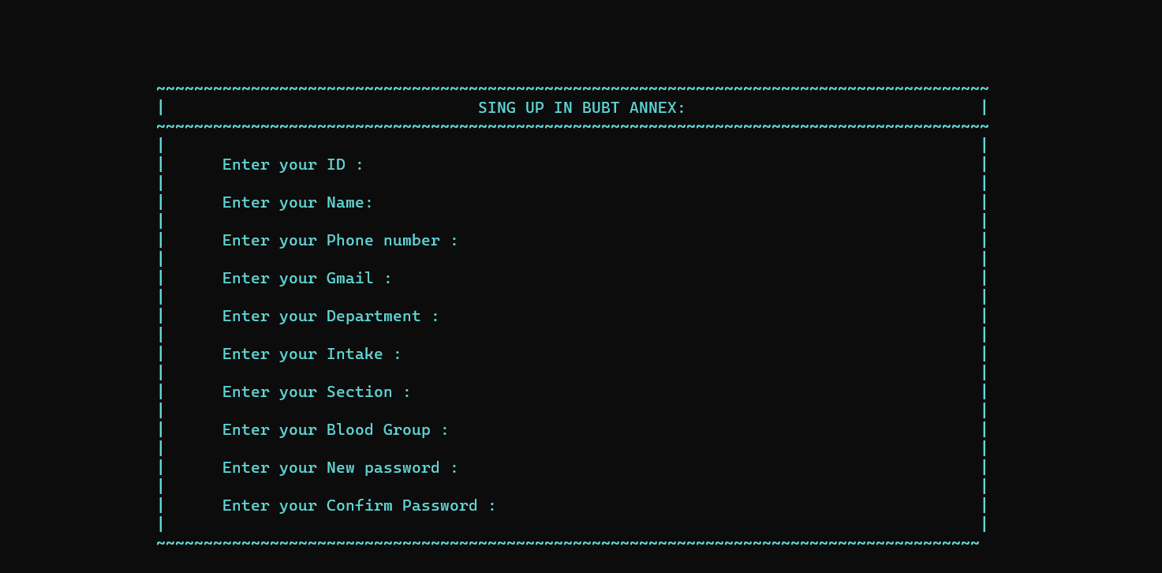

LOGIN SECTION

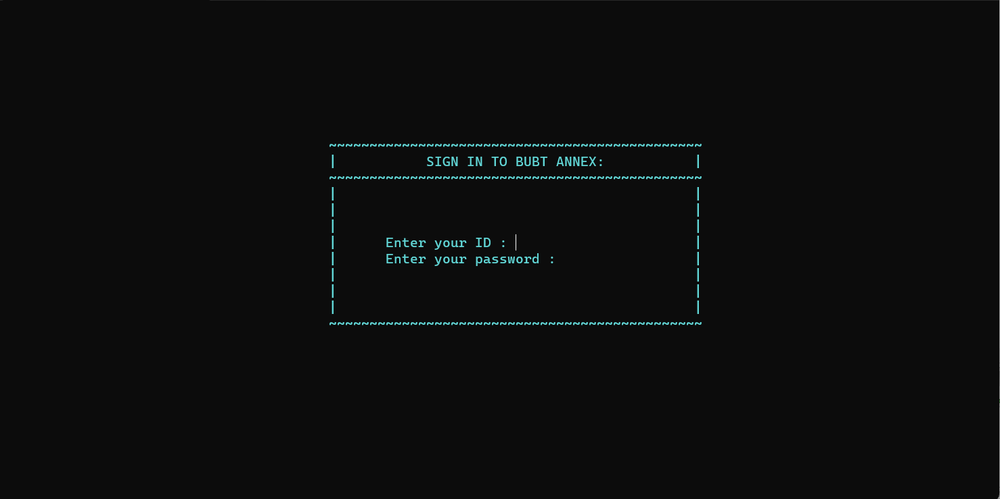

FORGOT PASSWORD

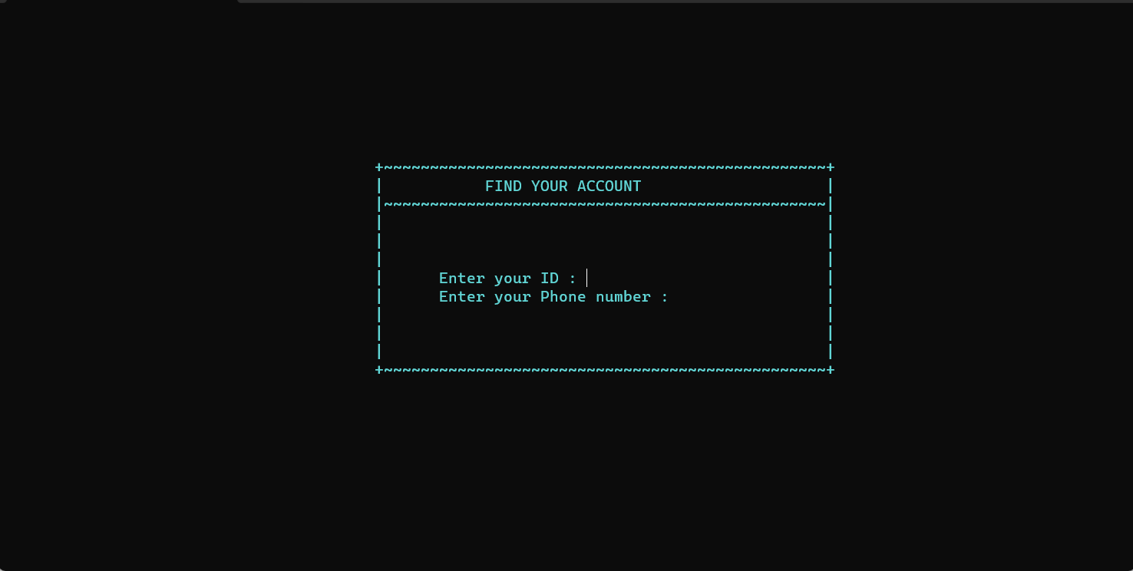

CONTACTS

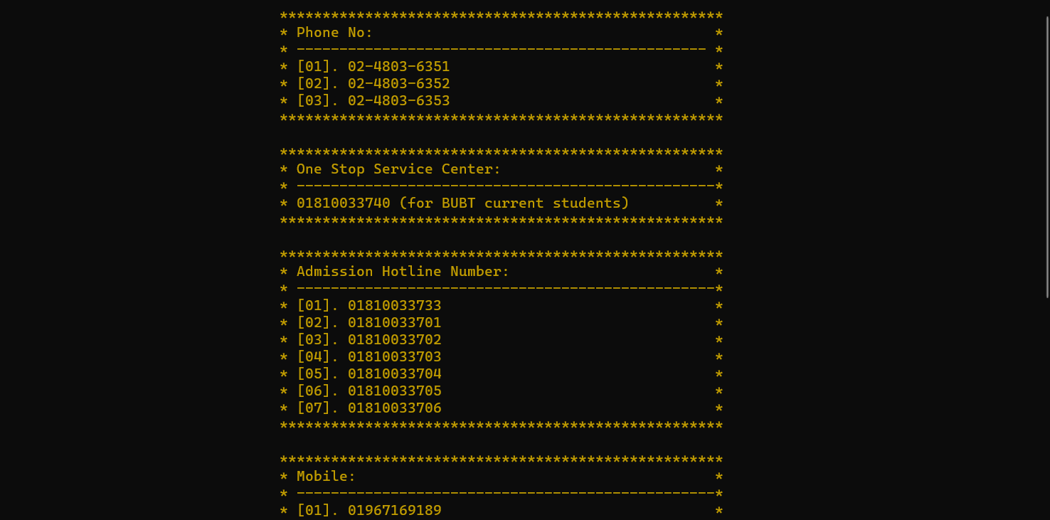







The system's potential for improvement includes refining the user interface, expanding integration capabilities, enhancing reporting, developing a mobile application, bolstering security, incorporating multi-language support, automating notifications, utilizing machine learning for predictive analytics, optimizing scalability, and integrating a feedback system.

The C++ Student Management System project has successfully addressed the core needs of educational institutions, covering tasks such as student registration, attendance tracking, grade management, and user authentication. The foundation is set for future enhancements to make it even more user-friendly and valuable. This project enriched our programming skills and deepened our appreciation for the importance of education technology in information management. The system is poised for ongoing improvements to maintain its relevance in education administration.



Back with solid fillGoogle